Corey Gaspar
3/8/2026
1-4 Assignment: Users and Solutions
Purpose
For this assignment, the mobile app I chose is iOS version of Spotify. Spotify is a popular music streaming platform that is designed to allow users to listen to audio content such as music, podcasts, and audiobooks anytime and from anywhere. The main task that Spotify helps users accomplish is streaming and discovering audio content quickly and easily.
The overarching goal of Spotify is to provide users with easy access to a large library of audio content that they enjoy, while also helping them discover new content with personalized recommendations. The design of the app supports this goal. On the Home page, the app shows the content that the user has recently listened to, as well as curated playlists and recommendations based on the user’s listening history. There are tabs at the bottom of the screen that allow users to quickly navigate through the app. The search tab allows users to search for songs, albums, artists, podcasts, or audiobooks, while the library tab allows users to access any content they have saved and to listen to or create custom playlists.

User Needs
Spotify is designed to meet several key user needs. The first one would be easy access to a large library of audio content. Users want to be able to listen to music, podcasts, or audiobooks at any time and from anywhere without needing to download individual audio files or paying for an individual song. Spotify fulfills this need by providing a large library of content that can be streamed instantly. A second need is discovering new content. Users may want to explore content that matches their tastes or try new genres, and Spotify supports this with personalized recommendations, curated playlists, and mixes based on listening history. A third key need is organizing personal content. Users may want to save content for later or create playlists for their favorite songs, and Spotify fulfills this through the Library feature, which allows users to save and organize their content for easy access later on.
Features
Spotify has many different features that make the app easy to use and meet user needs. At the top of the home page, it lists the playlists, artists, albums, or songs that the user has listened to recently, making it easy for them to jump back into their favorite music. There are also tabs at the top that let user’s switch between music, podcasts, and audiobooks. For example, if a user only wants to find podcasts, they can switch to the podcasts tab and it will only display podcast recommendations. If you scroll down more on the home page, it displays recently listened to albums and also shows different mixes and radios based on the user’s listening history. When listening to music, users have clear buttons for actions such as play, pause, shuffle, skip, and like, among others. The screenshot below shows what the home page of the iOS version of Spotify looks like:
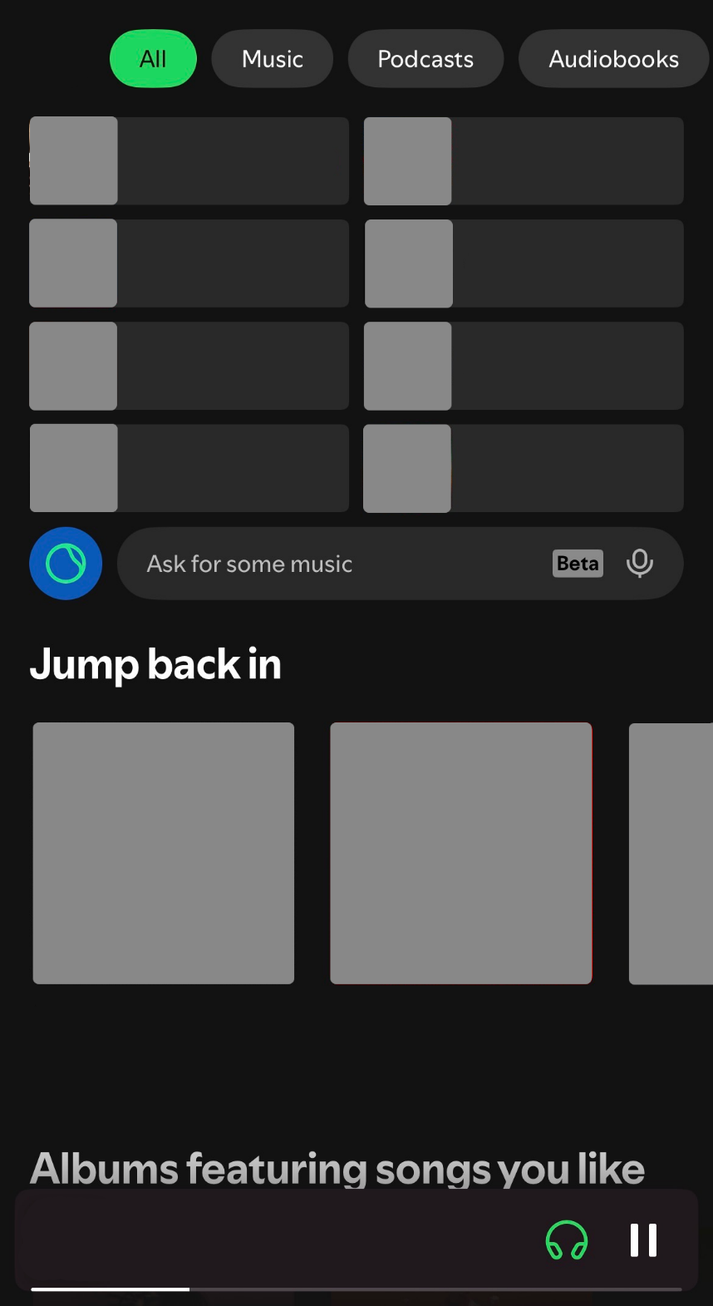

User Information
Before designing Spotify, it would be important for developers to gather information on their users’ goals and needs for the app. Developers would need to know what types of audio content users listen to the most, such as music genres, podcasts, and audiobooks, and how often they listen. This will help tailor the app’s personalization features. It would also be helpful to know how the users organize their content. For example, how do they save content and what types of playlists do they have for saving music. Developers should also consider the devices users have, their internet access, and where they typically listen to music. Finally, it would be important to know if users are willing to pay for the premium features, as that will guide subscription and design choices.

